# Exercise: Routing

Lab problem for the [“JavaScript Applications” course @ SoftUni](https://softuni.bg/courses/javascript-applications).

Submit your solutions in the SoftUni Page - <https://softuni.bg/trainings/2840/js-applications-june-2020/internal#lesson-15446>

# Team Manager

Create a JS application for managing teams. Use Handlebars for rendering, Sammy.js for routing and a remote database as a backend provider. Structure your work so that it is easy to manage. The example is styled using [Bootstrap](http://getbootstrap.com/).

## App Structure

* **Home Page** – show relevant info, depending on the status of the user
* **Catalog** – a list of all registered teams
* **About** – dummy page that would hold information about the app
* **Register User**
* **Create Team**
* **Edit Team**
* **View Team Details** – a detailed page that shows all members of the team and management controls

Create a header that is shared across all pages and place links to the relevant sections in it.

## CRUD Operations

The app must support user registration, login and logout. Store the user credential in **session storage**. Once logged in, the user is free to browse all registered teams and **join** or **create** a new team. At any point, the user is able to **leave** the team he is a member of. The user can only join **one** team at a time. Also when a user **creates** a team he **automatically** joins it. He **cannnot** create a team **again** unless he leaves the newly created team.

## Entity Structure

A team has a **name** and a **comment** that are displayed while browsing. A user has a **username**. You may create databases and entries as you see fit. A sample collection structure is as follows:

teams {

name,

comment

}

Add a column teamId to the default users collection, showing which team they have joined currently. When determining whether a person is the owner of a team, look at the property _acl.creator of the team record.

### Screenshots

Use this information as a guideline. You may style and structure your solution differently, as long as the required functionality is present.

Home page when the user is logged in and a header, that is shared across all pages.

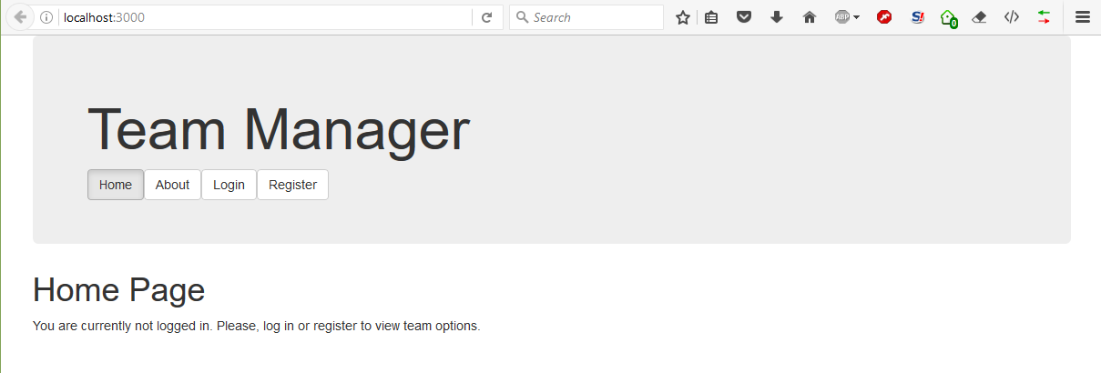

User registration form

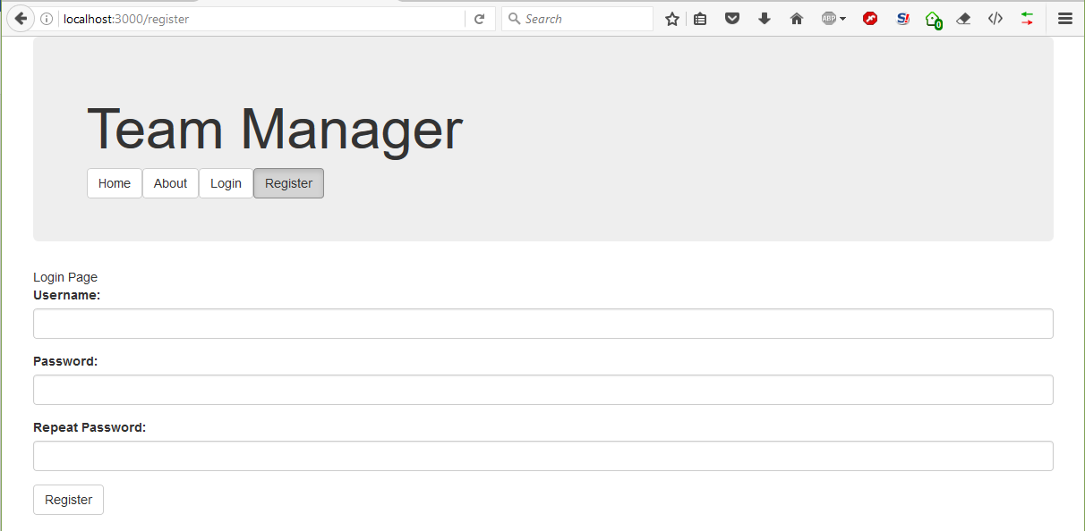

Login form

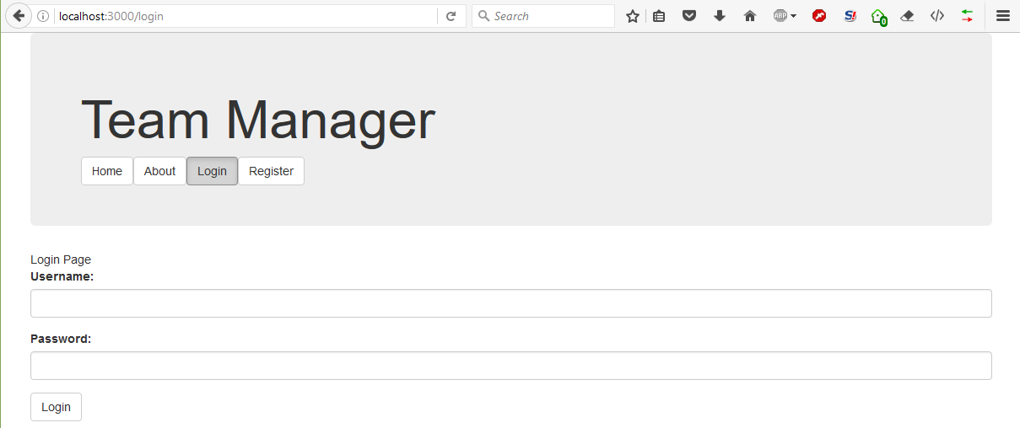

Home page view for a registered user. Note the header navigation has changed to reflect that.

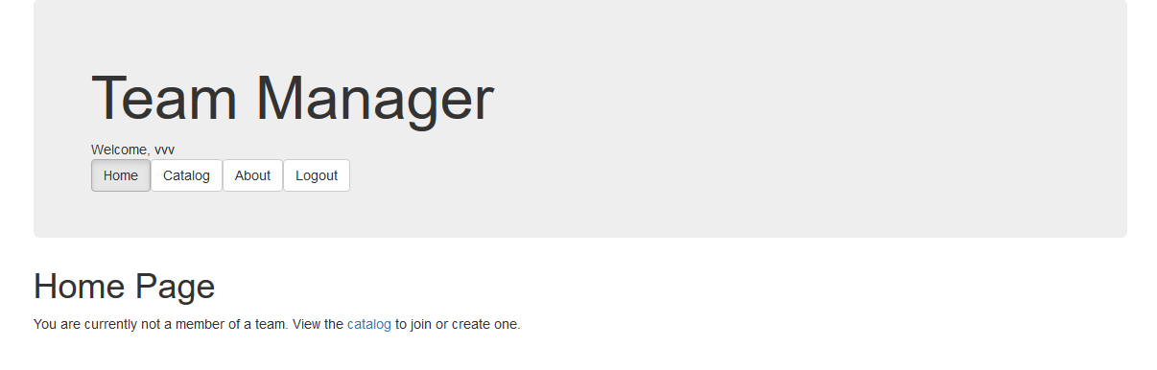

Team browser.

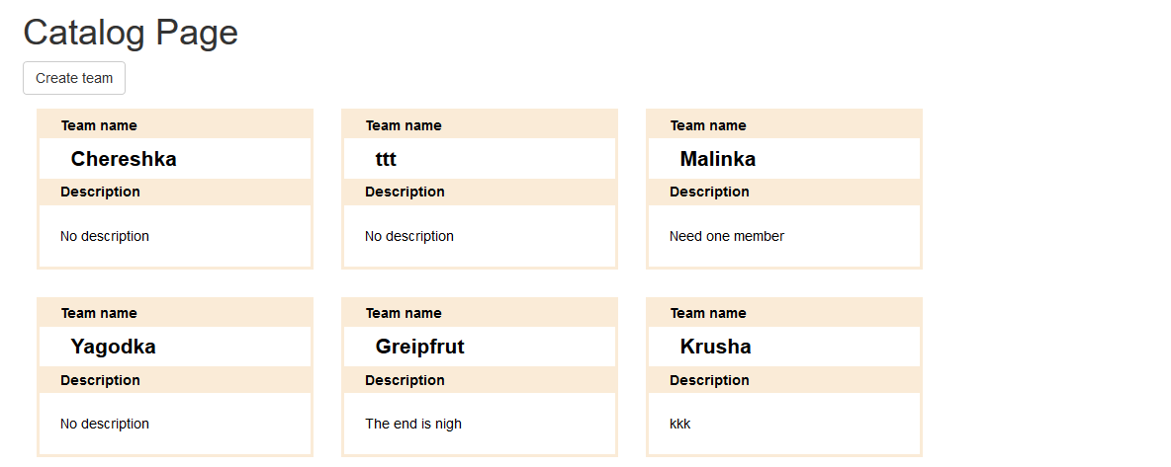

Create team and edit team forms are identical.  
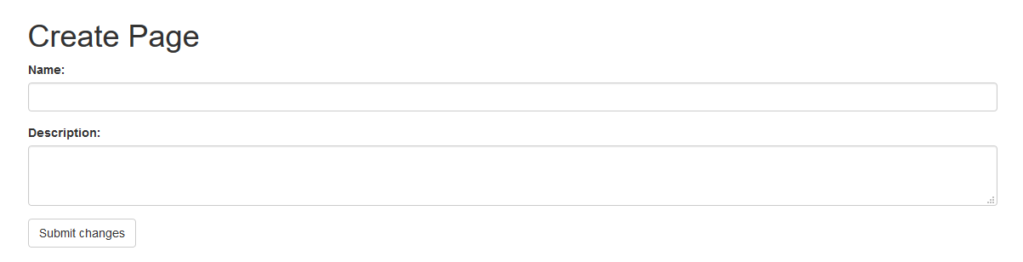

Team details with option to join the team and a list of all current members.

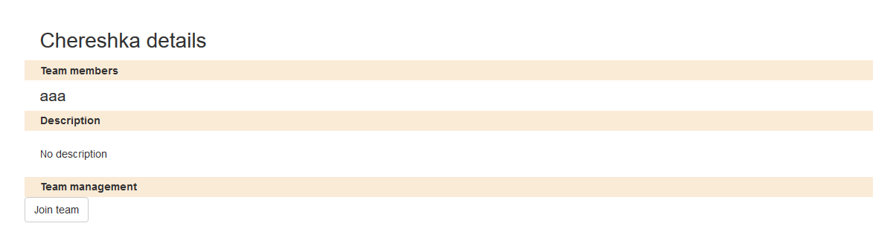

Team management. If the user is a member, they can leave the team. If the user is the creator, they can edit it.

<!-- Libraries -->

<script src="./node_modules/jquery/dist/jquery.js"></script>

<script src="./node_modules/bootstrap/dist/js/bootstrap.js"></script>

<script src="node_modules/handlebars/dist/handlebars.js"></script>

<script src="node_modules/sammy/lib/sammy.js"></script>

<script src="./node_modules/sammy/lib/plugins/sammy.handlebars.js"></script>